Canyon High School AP Lit.
Suggested Summer Assignment
Mrs. Kapp mkapp@hartdistrict.org
Ms. Goodwin vgoodwin@hartdistrict.org
(E-mails answered after Aug 1st.)

"If you don't have the time to read, you don't have the time or the tools to write."
--Stephen King
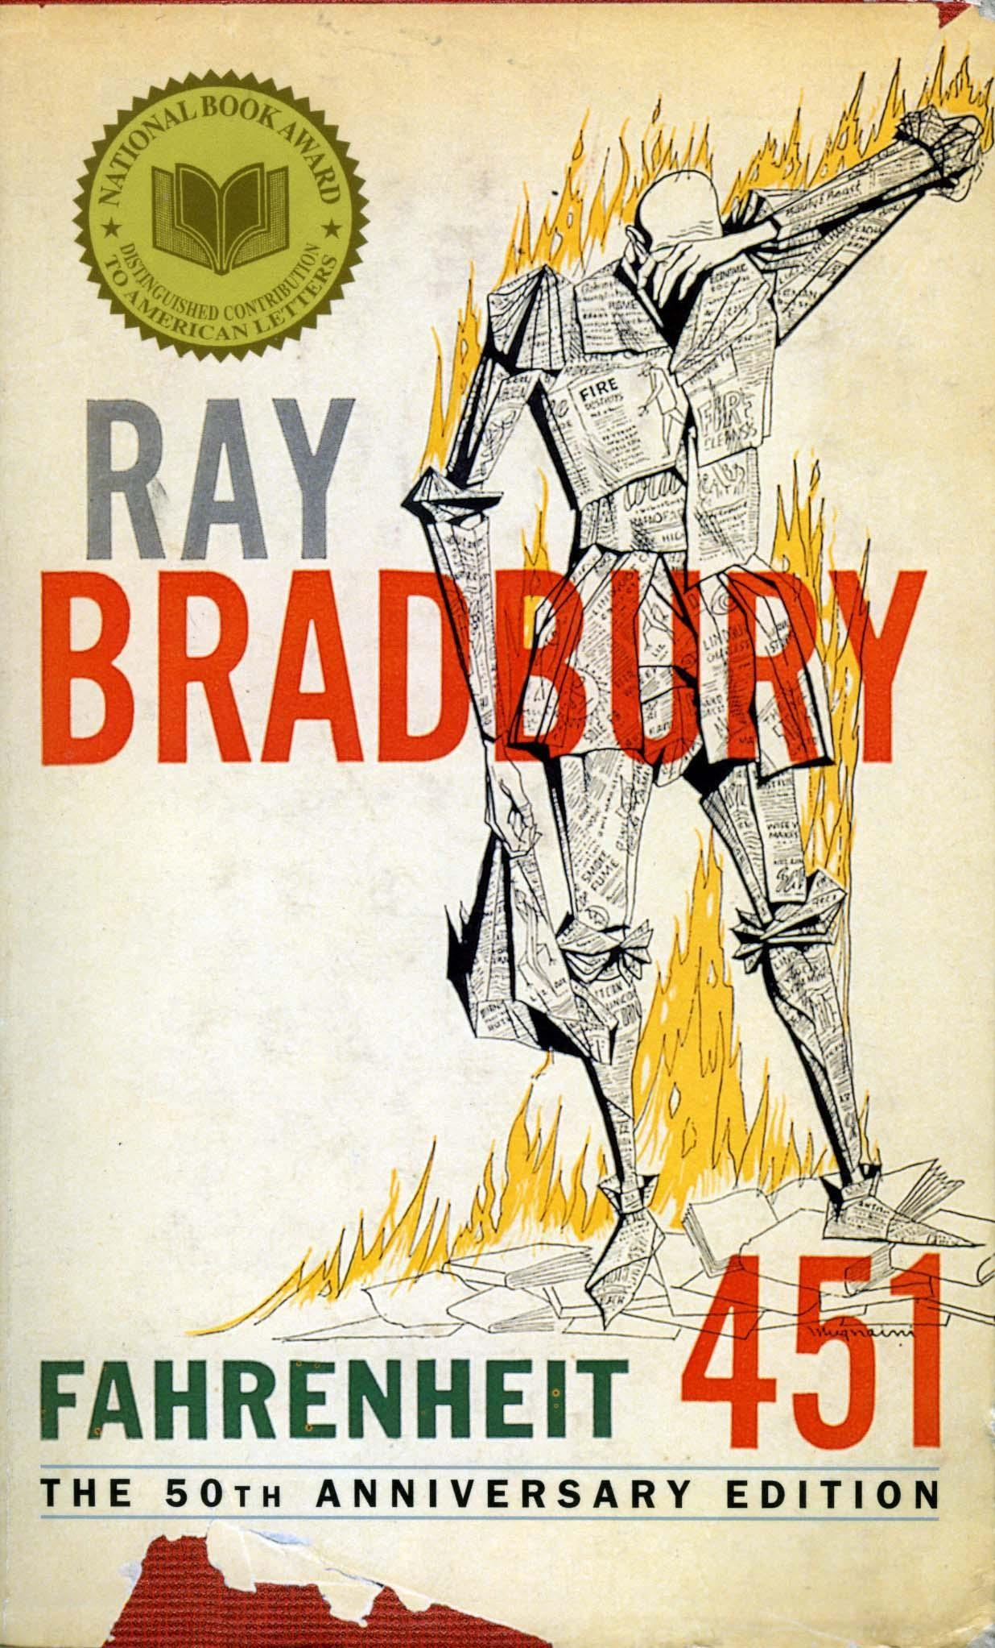
Purchase your own copy to read (optional), or get book from a library, and annotate:

Fahrenheit 451 by Ray Bradbury
➔ TO DO Over Summer
(RECOMMENDED) --OR-- DO when we return in August (DOABLE, BUT MOST STUDENTS WHO DO THIS, FIND IT CHALLENGING.)

Assignment Overview:
- Complete three (3) typed entries saved in one document called “Summer Reading Reader’s Notebooks” topics below.
- All 3 RNs saved as one document must be uploaded to turnitin.com when we return to school. (It must be submitted to Turnitin.com, for: Reading Notebooks (RNs) and book annotations.)
- Please realize that there will be additional nightly homework on top of this if you do not take advantage of the summer to complete the assignment!

THE TASK
1. Complete three (3) entries in “Reader’s Notebook” format and submit to TURNITIN.com – you will receive sign up code for Turnitin.com on the first day of school.
Each RN has 4 parts: Diction (Language Analysis +Vocab), Patterns, Analysis, and Key Passage (Quote + explanation). Use the following focus points for each RN. The Focus will mostly be addressed in the Analysis section.
- RN#1 Part I: Focus on the people and events that contribute to the protagonist’s change of view. What is Bradbury’s vision of the future?
- RN#2 Part II: Analyze the internal conflict the protagonist engages in now that he has undergone a transformation. Note the differing philosophies between major influences on Montag, such as Beatty, Faber, etc.
- RN#3 Part III: Examine the external conflict the protagonist wages to live his life in accordance with his new philosophy. What seems to be Bradbury’s message to his readers?

Advanced Placement Reading Notebook
Directions: Use a spiral notebook or composition book for your Reading Notebook. Leave the first page blank, as this will become your Table of Contents. Please date and title each of your entries with the title of the piece and the author. You must also indicate which genre of literature the selected piece is (i.e. novel, nonfiction, poetry, essay, etc.). Each entry should be approximately one to two pages. You may use the back of a page to finish an entry, but each entry should begin on the front of a new page.
You must respond to each of the categories below. Remember, you will be writing a reaction to each piece of literature we read during the year. The Reading Notebook is a major on-going project and will be required every day for class. I will collect it once a quarter at any time without warning, so be sure to keep the table of contents and entries well organized and current.
- Diction and Allusions
  - Note unfamiliar words and or allusions used by the author. Look them up prior to and during you reading of the selection.
- Patterns
  - Identify notable patterns of diction and syntax and how they affect the work. Explain how these patterns have certain connotations and /or how they develop the author’s tone, persona, or appeals to ethos, logos, or pathos.
  - For fiction, write a summary of the chapter or passage. For non-fiction, note the way that the author develops his argument.
  - For fiction, identify the key figures and explain how they are developing, changing or staying the same.
- Analysis
  - List the rhetorical strategies and figurative language that the author uses.
  - Identify and explain the author’s use of symbolism.
  - Soaps-tone
- Annotations
  - Annotate in your book or packet so that you are identifying key passages and the author’s use of rhetorical strategies, figurative language, and symbolism that you listed in your analysis, as well as, circling unknown words and allusions and underlining patterns of diction and syntax.
- Rhetorical Analysis
  - Write a Rhetorical Analysis paragraph explaining how the author’s use of the most significant rhetorical strategies including syntax, diction, figurative language, symbolism, and allusions (as well as other devices you have learned) develop the author’s overall purpose for the work. Be sure to cite at least three specific examples from your annotations in part IV.

